Lab 5.1 – Maximo Antigua

Refer to Tutorial 4: Graphic Design with CSS

1. Complete Session 4.1 pages HTML 274 to HTML 299

Add a screenshot of the **tb_komatsu.html** file displayed in a browser after completing Step 3 on page HTML 299. Refer to Figure 4-21 for reference. Include the browser address bar.

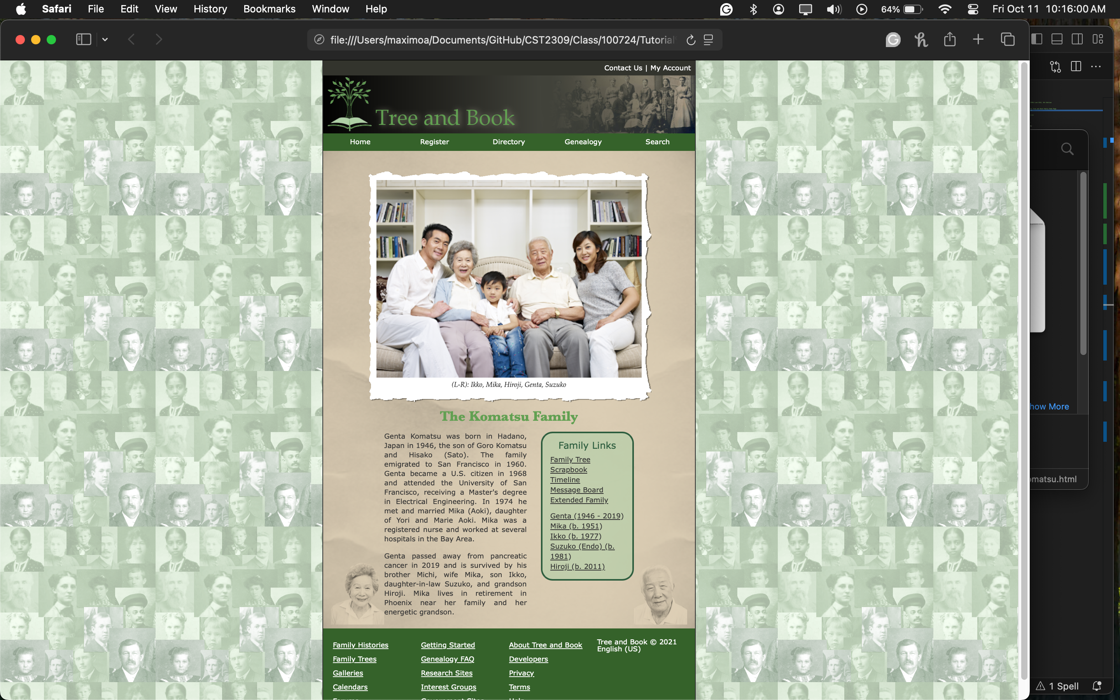

1. Complete the Session 4.1 Quick Check